1.1 OUTPUT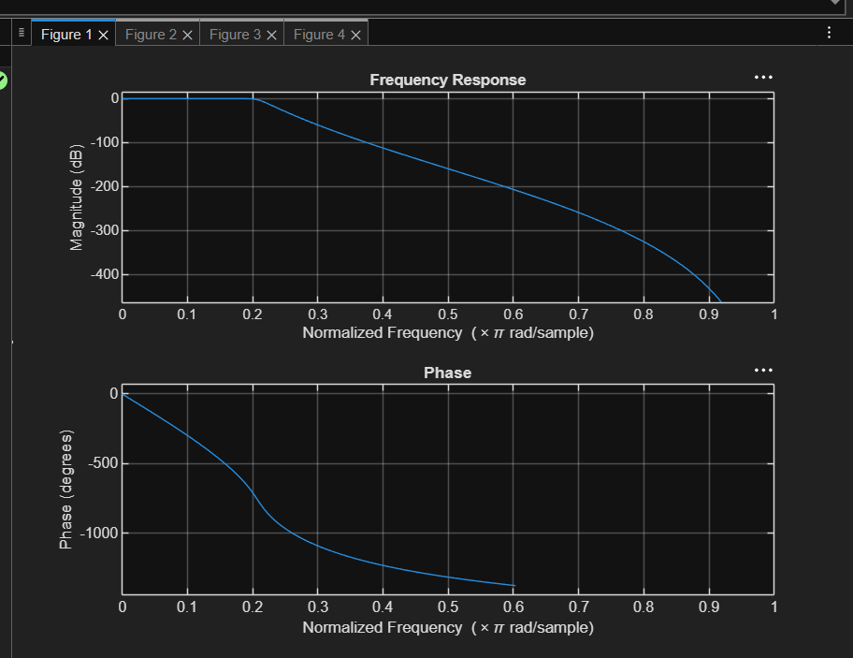
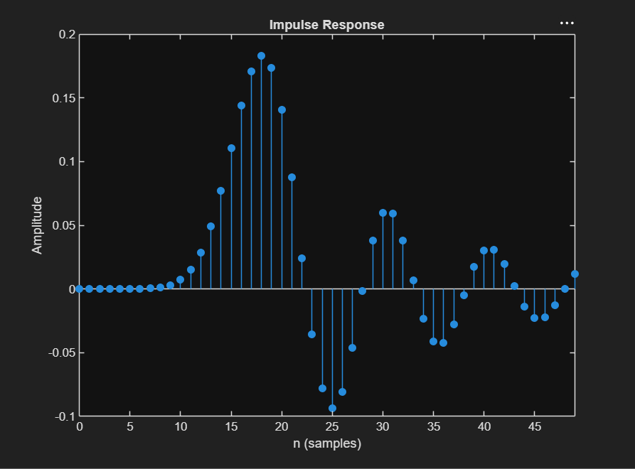
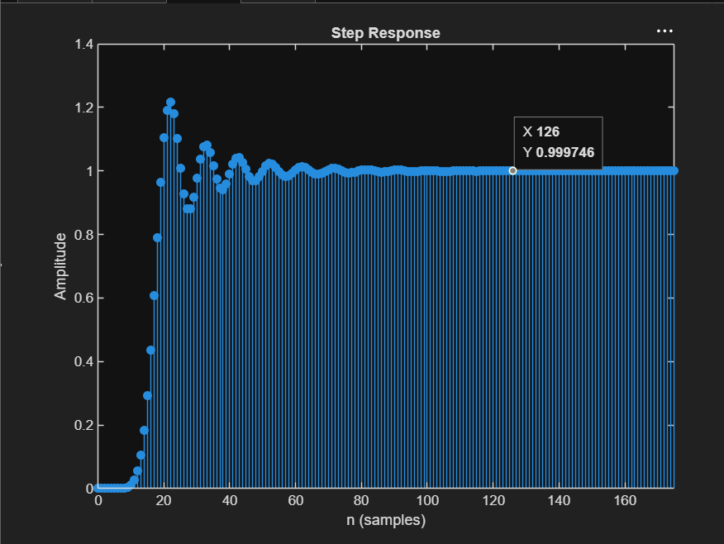
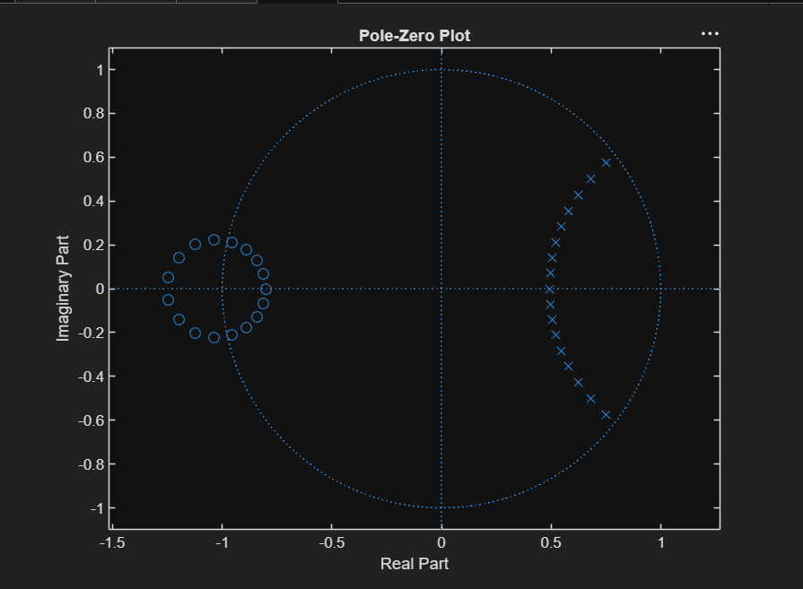
PROGRAM

clc;
clear;
close all;

% EX NO: 1 Butterworth IIR Filters
% Design and Analysis of a Butterworth IIR Low-Pass Filter Using MATLAB

Fs = 10000;
Fp = 1000;
Fst = 1500;

[N,Wn] = buttord(Fp/(Fs/2),Fst/(Fs/2),1,60);

[b,a] = butter(N,Wn);

% Frequency Response
figure;
freqz(b,a);
title('Frequency Response');

% Impulse Response
figure;
impz(b,a,50);
title('Impulse Response');

% Step Response
figure;
stepz(b,a);
title('Step Response');

% Pole-Zero Plot
figure;
zplane(b,a);
title('Pole-Zero Plot');

fprintf('Minimum Filter Order (N) = %d\n',N);
fprintf('Cutoff Frequency (Wn) = %.4f\n',Wn);

